Second Grade DBQ – Core Knowledge - Immigration

A Document Based Question (DBQ) is an authentic assessment whereby students interact with historical texts. A DBQ asks students to read and analyze historical records, gather information and fill in short scaffolding response questions, assimilate and synthesize information from several documents, and then respond (usually as a written essay) to an assigned task, by using information gleaned from the documents as well as their own outside information.
This DBQ is aligned with the Core Knowledge Listening and Learning domain, Immigration. It is meant to follow the unit so that students have already been exposed to the knowledge and vocabulary gained from the read alouds.
With prompting, scaffolding, and support, the students will review the series of pictures and text to determine the push and pull factors that brought immigrants to the United States. After reviewing the documents, students will write to the prompt independently.
Helpful Vocabulary:
immigrants | pull factor | homestead | freedom
immigrate | opportunity | settlers | liberty
push factor | emigrate | citizen | Ancestors

Writing Task:
A push factor is a reason that drives people away from a place, and a pull factor is a reason why people are drawn toward another place. Using evidence found in the following documents, your knowledge of our readings, and at least four of the vocabulary words from above, please describe the push and pull factors that brought immigrants to the United States.

Teacher Notes:
- Students should be given the opportunity to discuss the documents with partners and/or small groups. Students should not be expected to work through the documents independently. The teacher should monitor their understanding of the documents through whole group discussion before moving on to the independent writing task.
- As a teacher, you know your students and where they are on the developmental spectrum in writing. After the students have a solid understanding of the documents, the students are expected to tackle the writing piece independently. However, please scaffold and support this writing as needed by your students. For example, you could provide additional support through shared writing beforehand as an example, or provide additional graphic organizers as needed.
- Allow for several class sessions to complete this DBQ.

Name _____________________

Second Grade DBQ – Core Knowledge - Immigration

Helpful Vocabulary:
immigrants | pull factor | homestead | Freedom
immigrate | opportunity | settlers | Liberty
push factor | emigrate | citizen | Ancestors

Writing Task:
A push factor is a reason that drives people away from a place, and a pull factor is a reason why people are drawn toward another place. Using evidence found in the following documents, your knowledge of our readings, and at least four of the vocabulary words from above, please describe the push and pull factors that brought immigrants to the United States.

Document A

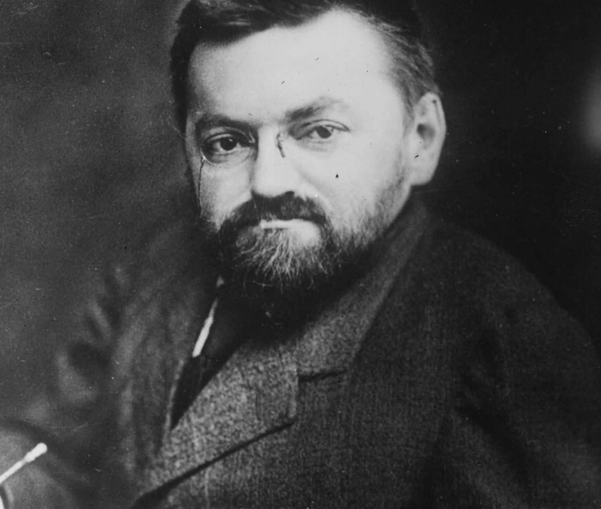
Charles Steinmetz was a man from Germany who stood only four feet tall, and whose body, instead of growing straight, seemed to bend to one side. He was a mathematician, or expert in mathematics, and an engineer – a person trained to design and build machines, bridges, or buildings. He had trouble finding work in Germany because he looked different. Many people did not understand that a powerful mind and kind heart lay inside Charles’s body. Charles had also written an article that said his nation’s government was to blame for many problems. In many countries, writing such an article could land a person in trouble. One day, a friend warned Charles, “My brother, who works for the government, says that the police are going to arrest you and put you in jail.” For these reasons, Charles left his home in Germany.
A friend named Oscar helped Charles immigrate to the United States by giving him the money he would need for a ticket on a ship. Oscar said, “There you can find work and be free to write or say what you think.” Charles agreed to go with him, but wondered, “Will they let me in after my trouble back home? Will they look at the way my body bends to one side and say I am too small and weak to be welcome in America?”
After arriving at Ellis Island, Charles began to learn English and went to work at a large company, using his powerful mind to invent useful new products. He helped improve the way electricity is carried through wires in order to bring electric power to buildings and houses. He helped to make electric streetlights possible and worked with the famous inventor, Thomas Edison. His friend Oscar later said, “Steinmetz came to America so he could help others with his talents and also have a good job and a life for himself. That is why they call the United States the ‘land of opportunity’.”

- What was different about the way Charles looked? How did people in Germany treat Charles?

- What were Charles’s strengths and talents?

- Why did Oscar think Charles might be arrested?

- In your own words, explain what happened to Charles after he immigrated to the United States.

- Why did Oscar say that the United States was the “land of opportunity”?

- List the reasons why Charles Steinmetz immigrated to the United States.

- What factors pushed Charles away from Germany?

- What factors pulled Charles toward the United States?

Document B
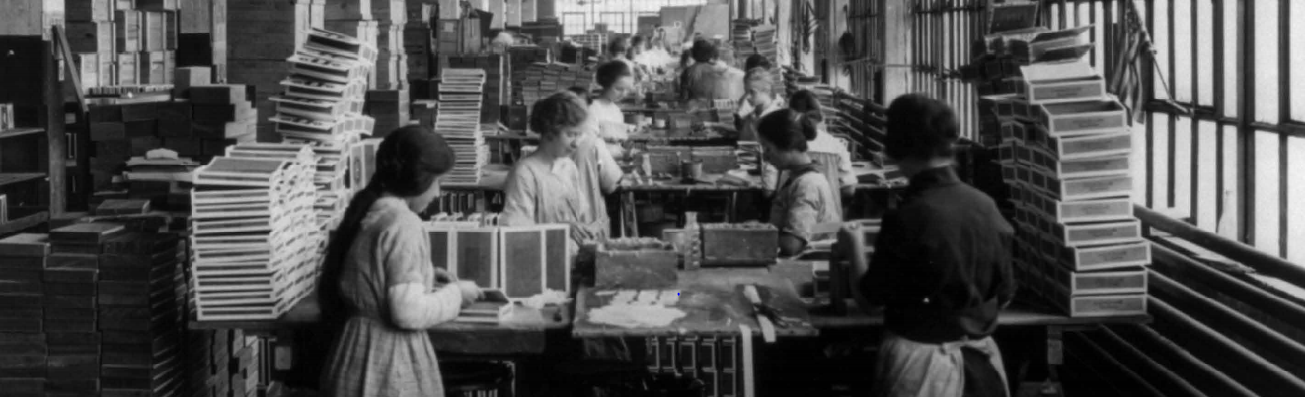
Many immigrants made their homes in the big cities of America. These immigrants settled in these large cities because there were jobs there. Back in their home countries, many of these people could find no work. City immigrants found work in factories, making everything from shirts to dresses to the buttons and buckles that closed them; from small wooden picture frames to huge wooden railroad cars; from loaves of bakery bread to huge ovens in which to do baking. The lives of many immigrants improved when they move to and settled in to these cities in the United States.

- Look carefully at the picture. Make a list of everything you see.
People | Objects | Actions

- Where are the women in this picture? What are they doing?

- Read the caption carefully. Why did immigrants come to large cities in America?

- List other reasons why these immigrants came to the United States.

- Were these reasons push or pull factors? Explain.

Document C
In Ireland in 1845, the main food crop was the potato crop. During this time, this crop suddenly died. This was called the potato blight of Ireland. When this happened, many people in Ireland had very little to eat, so many people decided to immigrate to the United States for a better life and job opportunities. Many Irish immigrants considered the United States to be the “land of opportunity” because although they worked just as hard in their home country, they had a lot less than they had in America.

- Look at the two pictures. What is the same about them? What is different?

- Read the caption carefully. In your own words, describe what happened in Ireland in 1845.

- Why did many Irish immigrants consider the United States to be a “land of opportunity”?

- List the reasons why Irish immigrants came to the United States.

- Were these reasons push or pull factors? Explain.

Document D

Like other immigrant groups, the Chinese came to America for many reasons. “Gold Mountain” or “Gam Saan” as the Chinese called it, was one of the main reasons the Chinese immigrated to the United States. After word reached China of the discovery of gold in the mountains of California, Chinese people were soon crossing the Pacific Ocean in large numbers, hoping to make their fortune. These immigrants entered the United States through the immigration center at Angel Island. They would claim, “There is a whole mountain made of gold gleaming in the sun. You just ship away pieces of the mountain and soon you are as rich as the Emperor of China!”

- Based on the information in the caption, what is the picture showing?

- Why did the Chinese call this the “Gold Mountain” or “Gam Saan”?

- In your own words, describe why the Chinese immigrants came to America.

- Does the quote “There is a whole mountain made of gold gleaming in the sun. You just ship away pieces of the mountain and soon you are as rich as the Emperor of China!” represent push or a pull factor? Was this quote true? How did quotes like this impact immigration?

Document E.1

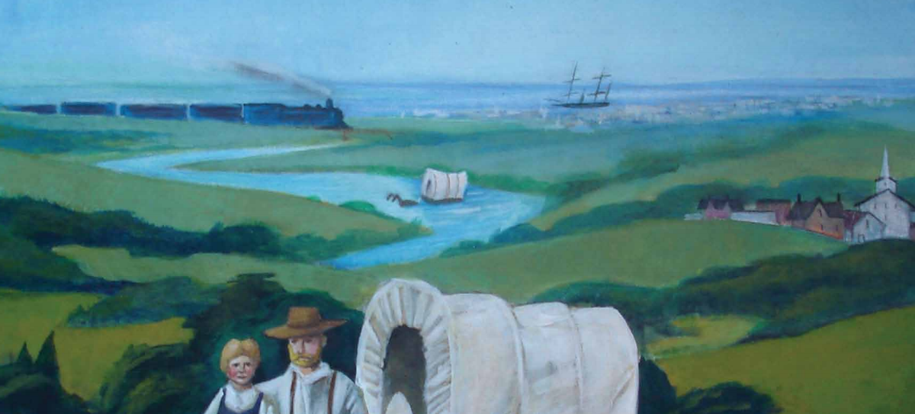

Document E.2
Some immigrants came from Northern Europe. They emigrated from countries like Germany, Norway, Sweden, and Denmark. These immigrants brought with them their knowledge of farming and a strong sense of working together as families and as neighbors. They came to the United States because they could not own land in Europe. In Europe, kings and princes kept tight control over who was allowed to buy and own land. People who were not friends of the king, or of a rich nobleman or noblewoman whose family had owned land for many years, had trouble buying farmland. Without owning farmland, it was hard for many people in Northern Europe to make a living.
During the American Civil War, in 1862, the American government under President Lincoln, gave huge amounts of government-controlled land to homesteaders. A homestead is land someone settles on to live and farm. The government made it easy to own as much as 160 acres of land, which was more than enough for a successful farm. A homesteader had to build a house on the land and farm the land for at least five years. At the end of that time, for a fee of eighteen dollars, the person or family would legally own the land.
Many different people could be homesteaders. People coming to America as immigrants could be homesteaders. The United States gave all sorts of people a chance to own land and make a new life. Millions of people came across the United States and immigrants from many other nations, including those in Europe, came to the Midwest to lend their farming skills and worked hard to build up the United States.

- Look carefully at the picture in Document E.1. Make a list of everything you see.

People | Objects | Actions

- Based on document E.2, why couldn’t most people in Europe own land?

- What did immigrants from Europe bring with them?

- Describe how the United States created a pull factor in the 1860’s.

- What did a homesteader need to do in order to own land in America?

- What connections can you make between Document E.1 and Document E.2?

- List the reasons why some immigrants from Northern Europe came to America.

- Were these reasons push factors or pull factors? Explain.

Make a t-chart listing all of the push factors and all of the pull factors that you found in the five documents.

Push Factors | Pull Factors

Name: _______________________________________
Writing Task: In one paragraph, describe the push and pull factors that brought immigrants to the United States.
- Use the t-chart to help you remember all of the push and pull factors that you found in each of the documents.
- Use at least one piece of evidence from each document. After a piece of evidence from a document, put the document letter in parentheses. For example, “George Washington was the top army general for the Continental Army (Doc. B).”
- Correctly use at least four of the vocabulary terms from this DBQ in your paragraph.
______________________________________________________________________________________________________________________________________________________________________________________________________________________________________________________________________________________________________________________________________________________________________________________________________________________________________________________________________________________________________________________________________________________________________________________________________________________________________________________________________
______________________________________________________________________________________________________________________________________________________________________________________________________________________________________________________________________________________________________________________________________________________________________________________________________________________________________________________________________________________________________________________________________________________________________________________________________________________________________________________________________
__________________________________________________________________________________________________________________

