Second Grade DBQ – Core Knowledge - The War of 1812

A Document Based Question (DBQ) is an authentic assessment whereby students interact with historical texts. A DBQ asks students to read and analyze historical records, gather information and fill in short scaffolding response questions, assimilate and synthesize information from several documents, and then respond (usually as a written essay) to an assigned task, by using information gleaned from the documents as well as their own outside information.
This DBQ is aligned with the Core Knowledge Listening and Learning domain, The War of 1812. It is meant to follow the unit so that students have already been exposed to the knowledge and vocabulary gained from the read alouds.
With prompting and support, the students will review the series of pictures and text to determine the factors that contributed to the start of the War of 1812. After reviewing the documents with partners and/or the whole group, students will write to the prompt independently.
Helpful Vocabulary:
trade | blockade | seize | impressment
farmer | merchant | citizen | economy
navy | sailor | suspicious | soldier

Writing Task:
Using evidence found in the following documents, your knowledge of our readings, and the at least four of the vocabulary words from above, please describe the events that contributed to the start of the War of 1812.

Teacher Notes:
- Students should be given the opportunity to discuss the documents with partners and/or small groups. Students should not be expected to work through the documents independently. The teacher should monitor their understanding of the documents through whole group discussion and individual group monitoring before moving on to the independent writing task.
- As a teacher, you know your students and where they are on the developmental spectrum in writing. After the students have a solid understanding of the documents, the students are expected to tackle the writing piece independently. However, please scaffold and support this writing as needed by your students. For example, you could provide additional support through shared writing beforehand as an example, or provide additional graphic organizers as needed.
- Allow for several class sessions to complete this DBQ.

Name _____________________

Second Grade DBQ – Core Knowledge - The War of 1812

Helpful Vocabulary:
trade | blockade | seize | impressment
farmer | merchant | citizen | economy
navy | sailor | suspicious | soldier

Writing Task:
Using evidence found in the following documents, your knowledge of our readings, and the at least four of the vocabulary words from above, please describe the events that contributed to the start of the War of 1812.

Document A
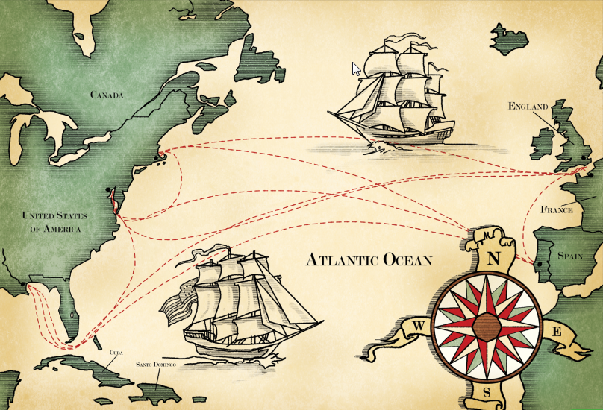

- Look carefully at the map. What countries are labeled on the map?

- What do you think the dotted lines represent?

- What do the ships represent?

- How does this document help to explain a reason why the War of 1812 began?

Document B
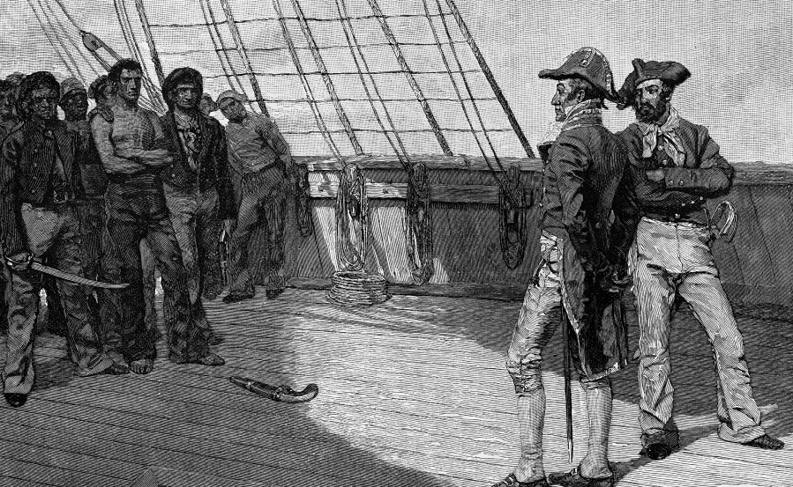

- Make a list of everything you see.
People | Objects | Actions

- Where are men in this picture? Describe the expressions on the men’s faces.

- Based on what you have learned about the time period, why do the men have these expressions?

- What connection can you find between Document A and Document B?

- How does this document help to explain a reason why the War of 1812 began?

Document C
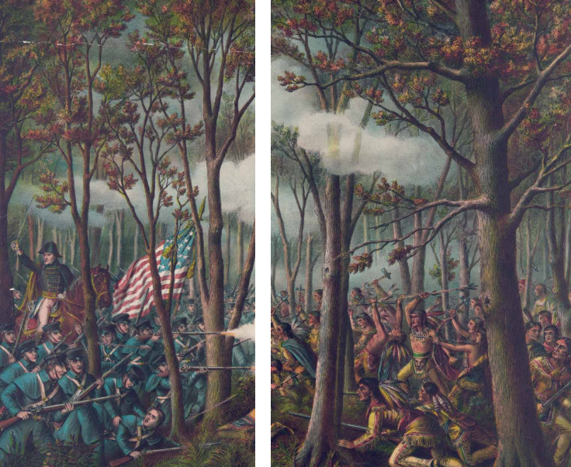

- Make a list of everything you see.
People | Objects | Actions

- Describe the two groups of people in each picture.

- Based on what you know about the time period, why would these two groups be fighting?

- How does this document help to explain a reason why the War of 1812 began?

Document D

Presidents have to make hard choices. James Madison had to decide whether to side with the War Hawks or with the merchants. The War Hawks felt a war was needed. They were scared of Native Americans. They were angry with the British. They complained about impressment. They complained that the British were selling guns to Native Americans. The merchants did not want war. War would mean less trade between countries. War would mean sunken ships and lost goods. In the end, President Madison sided with the War Hawks. On June 18, 1812, the United States declared was on Great Britain.
The Americans were in for a hard fight. The British had a huge army. They also had the world’s biggest navy. But the British were already at war with France. They could only send some of their troops to fight the United States. That was a good thing for the Americans. It meant that the United States would have a better chance of winning.

- Why did the War Hawks want to go to war?

- Why didn’t the merchants want to go to war?

- Why were the Americans in for a hard fight?

- What gave the Americans a chance of winning?

- How does this document help to explain a reason why the War of 1812 began?

Name: _______________________________________
Writing Task: In one paragraph, describe the events that contributed to the War of 1812.
- Use at least one piece of evidence from each document. After a piece of evidence from a document, put the document letter in parentheses. For example, “George Washington was the top army general for the Continental Army (Doc. B).”
- Correctly use at least four of the vocabulary terms from this DBQ in your paragraph.

______________________________________________________________________________________________________________________________________________________________________________________________________________________________________________________________________________________________________________________________________________________________________________________________________________________________________________________________________________________________________________________________________________________________________________________________________________________________________________________________________
______________________________________________________________________________________________________________________________________________________________________________________________________________________________________________________________________________________________________________________________________________________________________________________________________________________________________________________________________________________________________________________________________________________________________________________________________________________________________________________________________
__________________________________________________________________________________________________________________

