Second Grade DBQ – Core Knowledge – Westward Expansion

A Document Based Question (DBQ) is an authentic assessment whereby students interact with historical texts. A DBQ asks students to read and analyze historical records, gather information and fill in short scaffolding response questions, assimilate and synthesize information from several documents, and then respond (usually as a written essay) to an assigned task, by using information gleaned from the documents as well as their own outside information.
This DBQ is aligned with the Core Knowledge Listening and Learning domain, Westward Expansion. It is meant to follow the unit so that students have already been exposed to the knowledge and vocabulary gained from the read alouds.
With prompting, scaffolding, and support, the students will review the series of pictures and text to determine how and why people moved west during westward expansion. After reviewing the documents and creating a graphic organizer with partners and whole group, students will write to the prompt independently.
Helpful Vocabulary:
settled | covered wagon | relocate | route
steamboat | transport | transcontinental | convenient
canal | forced | railroad | territory

Writing Task:
Using evidence found in the following documents, the t-chart you created, your knowledge of our readings, and at least four of the vocabulary words from above, please write one paragraph explaining how people moved west during westward expansion. Then write another paragraph explaining how people moved west during this time period.

Teacher Notes:
- Students should be given the opportunity to discuss the documents with partners and/or small groups. Students should not be expected to work through the documents independently. The teacher should monitor their understanding of the documents through whole group discussion before moving on to the independent writing task.
- As a teacher, you know your students and where they are on the developmental spectrum in writing. After the students have a solid understanding of the documents, the students are expected to tackle the writing piece independently. However, please scaffold and support this writing as needed by your students. For example, you could provide additional support through shared writing beforehand as an example, or provide additional graphic organizers as needed.
- This DBQ includes a graphic organizer (t-chart) to help students organize their thoughts before beginning the writing assignment.
- Allow for several class sessions to complete this DBQ.

Name _____________________

Second Grade DBQ – Core Knowledge – Westward Expansion

Helpful Vocabulary:
settled | covered wagon | relocate | route
steamboat | transport | transcontinental | convenient
canal | forced | railroad | territory

Writing Task:
Using evidence found in the following documents, the t-chart you created, your knowledge of our readings, and at least four of the vocabulary words from above, please write one paragraph explaining how people moved west during westward expansion. Then write another paragraph explaining how people moved west during this time period.

Document A.1
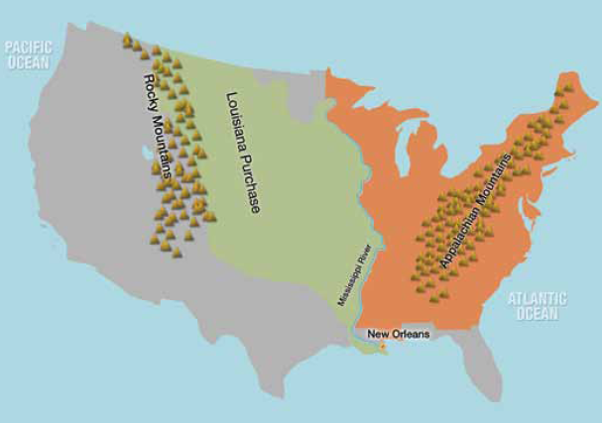
Document A.2

- Look carefully at the map in Document A.1. Describe the colored areas you see. Why was the country divided into these areas during this time period?

- Look carefully at Document A.2. Describe the objects and animals in the photo. Based on the time period, where might these people be going?

- How do Document A.1 and Document A.2 relate to each other?

- What did you learn from this document about why people moved west? What did you learn about how people moved west?
Document B.1 Document B.2
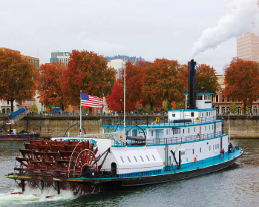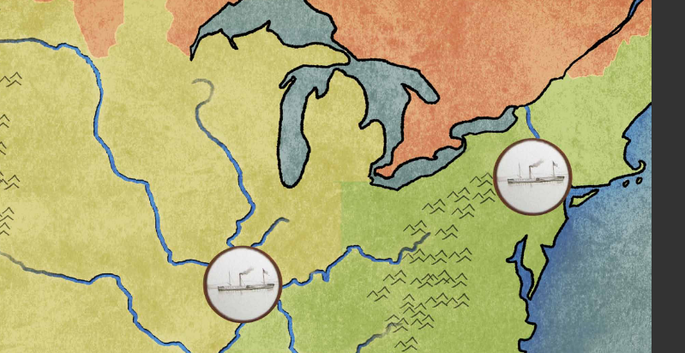
Document B.3
Before folks built the Erie Canal, it took longer to move things from the East westward. Because a flatboat floats on water, it’s much easier to transport heavy freight like coal and wood. It also costs less money to travel on canals than over land. For every dollar it cost to travel on land, it only cost about a dime to travel on the canal’s water. Moving out to the West seemed like a good idea once the people knew they could sell whatever they grew or made to folks back in the East, as well as to people in the West.

- Look carefully at Document B.1. What type of boat is this? How can you tell?

- How did the boat pictured in Document B.1 help people during the time of westward expansion?

- Look carefully at Document B 2. What objects are in the white circles? What does the color blue represent?

- What are the blue lines in Document B.2? Describe where the blue lines are connecting.

- How many pennies is a dime worth? _____ How many pennies is a dollar worth? _____
What is the difference between a dime and a dollar? _____

What does this tell you about how much it cost to travel on land and how much it cost to travel on water during this time period?

- How did the creation of the canals and the boats help people during this time period?

- What did you learn from this document about why people moved west? What did you learn about how people moved west?

Document C.1
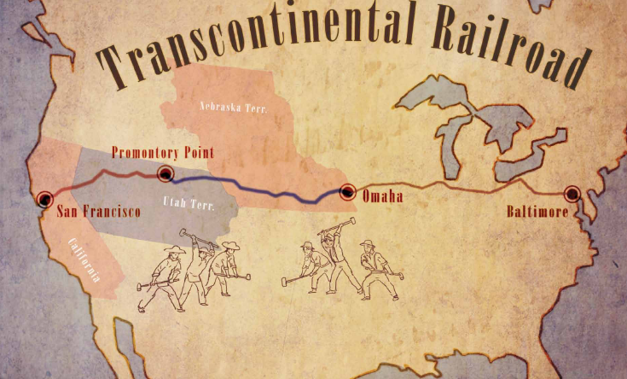
Document C.2
Railroads were a cheaper, more comfortable, and more convenient way for people to travel than by covered wagon or canal. It was faster, too. Before the transcontinental railroad, people could only travel to the West by wagon or horse, or by boat on a river or canal, and the going was slow.

- What is the title of the map in Document C.1?

- Make a list of places listed on the map.

- Based on the time period, what are the men doing in this picture?

- What does the line in the middle of the country represent?

- Based on document C.2, why were railroads built during westward expansion?

- What did you learn from this document about why people moved west? What did you learn about how people moved west?

Document D.1

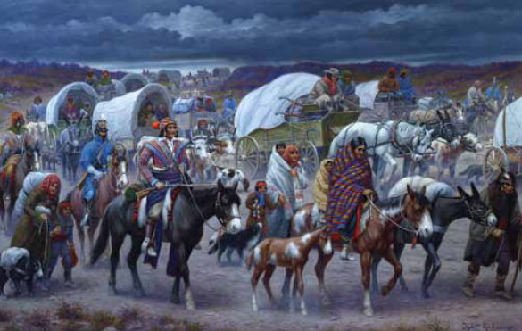
\
Document D.2
The white settlers began asking, “Why don’t the Cherokee move? Our government can offer them land farther west and we can keep their farms and businesses for ourselves.” The Cherokee did not want to leave and were afraid the government would force them to move west. One Cherokee, John Ross, pleaded with the government not to relocate the tribe. The government didn’t listen. The U.S. government leaders told the Cherokee they would pay them two million dollars if they moved. President Jackson insisted the Cherokee move to what was called the “Indian Territory”. He sent soldiers to make them go. The Cherokee had a long, difficult journey with a lack of supplies. They encountered a terrible snowstorm along the way. Many died during the storm and others were too weak to continue after the storm had ended. So many died along the way that the survivors called the journey the “Trail of Tears”, and it has been known as that ever since.
- Make a list of everything you see in Document D.1.
People | Objects | Actions

- Who wanted the Cherokee to move? Why did they want them to go?

- Where were the Cherokee moving?

- What happened to the Cherokee along the journey?

- Why was their journey called “The Trail of Tears?”

- What did you learn from this document about why people moved west? What did you learn about how people moved west?

- How is the reason the Cherokee moved west different from other reasons you have learned about?

Look back at the documents and think about how people moved west during westward expansion. Then, think about why people moved during westward expansion. Create a list of notes in the t-chart using evidence from each of the documents to show how and why people moved west during this time period.

How people moved west Why people moved west

Name: _______________________________________
Writing Task: In one paragraph, describe how people moved west during westward expansion. In another paragraph, describe why people moved west during westward expansion.
- Look back at your t-chart and your notes.
- Use at least one piece of evidence from each document. After a piece of evidence from a document, put the document letter in parentheses. For example, “George Washington was the top army general for the Continental Army (Doc. B).”
- Correctly use at least four of the vocabulary terms from this DBQ in your paragraph.
______________________________________________________________________________________________________________________________________________________________________________________________________________________________________________________________________________________________________________________________________________________________________________________________________________________________________________________________________________________________________________________________________________________________________________________________________________________________________________________________________
______________________________________________________________________________________________________________________________________________________________________________________________________________________________________________________________________________________________________________________________________________________________________________________________________________________________________________________________________________________________________________________________________________________________________________________________________________________________________________________________________
__________________________________________________________________________________________________________________

