Teacher Notes
3RD Grade DBQ for The Ancient Roman Civilization
A DBQ (Document Based Question) is an authentic assessment where students interact with historical texts. A DBQ asks students to read and analyze historical records, gather information and fill in short scaffolding response questions, assimilate and synthesize information from several documents, and then respond in writing to an assigned task, by using information gleaned from the documents, as well as, their own outside information.
This DBQ is aligned with the Nevada Academic Content Standards for Listening and Learning Domain. It is meant to follow the completion of the unit, so that students have already been exposed to the knowledge and vocabulary gained from the read-alouds. The specific standards that are supported in this DBQ are RI.3.3, RI.3.7, RI.3.9, W.3.8, SL.3.1A, SL.3.1B, SL.3.1C, SL.3.1D, SL.3.3, SL.3.4, SL.3.6, L.3.3A, L.3.4C, and L.3.6. These standards are met through teacher led document discussions. Our recommendation is to lead and complete one document with your class per day. Only the culminating writing task is done independently.
With prompting and consistent teacher support through the whole process, students will review the series of pictures and think about what similarities and differences between the Roman Republic social classes. The teacher will show the images, ask the accompanying questions and allow pairs to discuss their answers (these do not need to be answered in writing). After reviewing the documents, in teacher led discussion, students will write to the task independently.

Name _______________# _____

Third Grade DBQ-Core Knowledge- The Roman Republic
Helpful Vocabulary:
patrician plebeians consuls attributes
senators slaves elite rivalries
loyalty republic government society
citizen

Writing Task:
Using evidence found in the following documents, your knowledge of our readings, and at least 6 of the vocabulary words from above, compare and contrast the similarities and differences of the three social groups in the Roman Republic.

Document A
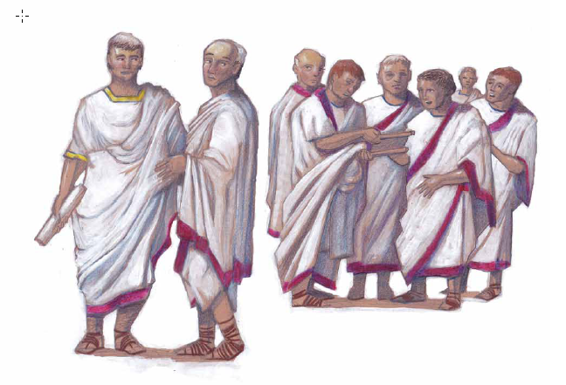
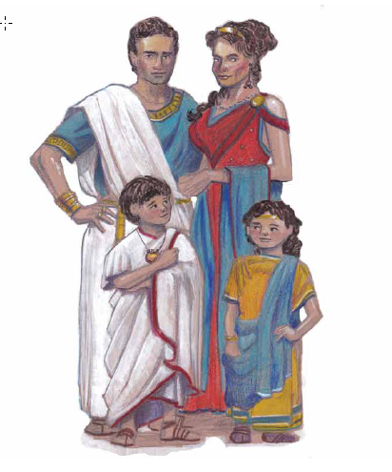
- Look at the pictures and make a list of everything you see.
People | Objects/Clothing | Actions/Expressions

- Describe the differences between the first picture and the second picture.

- What connection can you find between the pictures?

- Based on what you have learned about these people, what social class do they belong to?

Document B
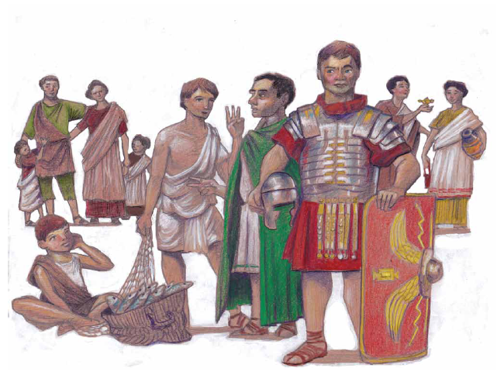

- Look closely at the picture and make a list of everything you see.
People | Objects/Clothing | Actions/Expressions

- What evidence in this picture tells you what social class these people belong to?

- How are the people shown in Document B different from those shown in Document A?

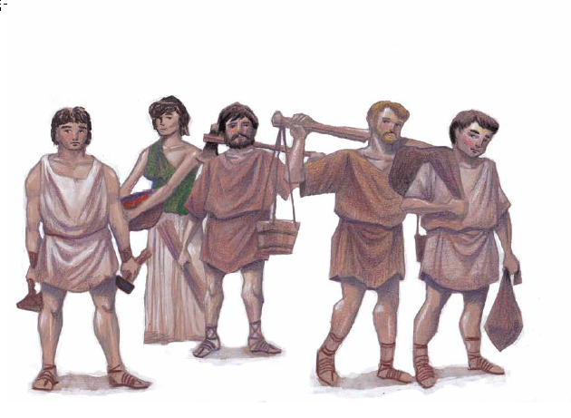
Document C

- Look closely at the picture and make a list of everything you see.
People | Objects/Clothing | Actions/Expressions

- What evidence from this picture tells you what social class they belong to?

- How are the people in Document C different from those in Documents A and B?

Document D
Instead of having a king make all the laws and tell everyone else what to do, the Romans decided that the citizens-the people-should be able to elect those who would work together to make decisions and form laws to guide how their society was ruled. In this new form of government, the people had more of a voice in how their society would be ruled as a republic.
In the early years of the Roman Republic, one group held most of the power. These were the Patricians. They were the smallest and most powerful group. They were Rome’s elite. The Patricians were from wealthy, old families, whose men could be elected to the Roman Senate. The Senate was made up of 300 Senators. The people elected two consuls, two people whose job it was to make final decisions on whether a new law should be passed. They had the power to command the army and were advised by the Senate. Senators held their position for as long as they lived and debated over what kinds of laws were needed in Rome.
Another group of Roman citizens were called Plebeians. Plebeians were second class citizens, meaning they did not have all the rights and privileges enjoyed by Patricians. The Plebeians made up the largest portion of Roman society. The wealthy Patricians learned they needed to make sure the Plebeians were happy so they wouldn’t rise up and try to take more power for themselves. Like Patricians, Plebeians were citizens so they could vote. However, they were subject to a different set of laws. Plebeians came in all shapes and sizes, including fairly wealthy shopkeepers and traders, hard-working farmers and fisherman.
The final group that completed the Roman society were the slaves. Slaves were not considered citizens of Rome, so they could not vote. Slaves belonged to their owners, so they did not have the freedom to do as they pleased. The slaves could not choose where to live or work, or what job they got to do. Roman slaves did have some rights. For instance, Roman slaves were allowed to receive as much education as they needed to be better at their job. After some time, if slaves worked very hard for their owner, they could earn their freedom. Once slaves were given their freedom, their children were considered full Roman citizens. Slaves were considered the lowliest people in Roman society, at the other end of the spectrum from the elite class (Patricians).
Whether patrician, plebeian, or slave; man, woman, or child - all of the people of ancient Rome contributed in their own ways to the many components of this ancient civilization.
- The Romans decided not to have a king. Using evidence from the first paragraph describe the type of government they set up instead. (Make sure you give details about what makes a republic.)

- Fill in the blank spots in the following chart about the different groups of people in Roman society. Underline vocabulary words used.
Social Group | Size of the Group | Rights | Jobs/Wealth | Role in Government
-Could Vote
-Could be elected to serve in Senate

Plebians
 | Not known
Name:_________________________________ #________
WRITING TASK
Writing Task: Compare and contrast the similarities and differences of the Roman Republic
- Use at least six vocabulary words from this DBQ in your writing.
- Use at least one piece of evidence from each document to compare and contrast the different classes of people in the Roman Republic.
- After each piece of evidence, put the document letter in parentheses. For example, “In the early years of the Roman Republic, one group held most of the power. These were the Patricians.” (Doc. D)

__________________________________________________________________________________________________________________________________________________________________________________________________________________________________________________________________________________________________________________________________________________________________________________________________________________________________________________________________________________________________________________________________________________________________________________________________________________________________________________________________________________________________________________________________________________________________________________________________________________________________________________________________________________________________________________________________________________________________________________________________________________________________________________________________________________________________________________________________________________________________________________________________________________________________________________________________________________________________________________________________________________________________________________

