Kindergarten DBQ – Core Knowledge: Colonial Workers

A Document Based Question (DBQ) is an authentic assessment whereby students interact with historical texts. A DBQ asks students to read and analyze historical records, gather information and fill in short scaffolding response questions, assimilate and synthesize information from several documents, and then respond in writing to an assigned task, by using information gleaned from the documents as well as their own outside information.
This DBQ is aligned with the Core Knowledge Listening and Learning domain, Colonial Towns and Townspeople and supports NVACS H1.K1, H1.K3, H3.K2, E9.K1, W.K.2, SL.K.1, RI.K.1, . It is meant to follow the Core Knowledge unit so that students have already been exposed to the knowledge and vocabulary gained from the read alouds.
With prompting and support, the students will review the series of pictures and think about the tools colonial people used to do important jobs. The teacher will show the images, ask the accompanying questions and allow pairs to discuss their answers (these do not need to be answered in writing). After reviewing the documents, students will write to the task independently.
Helpful Vocabulary to Post During DBQ and Refer To For Writing Task:
weave | knead | loom | garment
spindles | loaves
Writing Task:
What tools did Colonial people use to do important jobs in their homes?
- Use four of the vocabulary words in your writing.
- Use evidence from each document.
- Use your background knowledge from the unit.

Teacher Notes:
- When guiding students in pairs to discuss the documents, you should project them on the board as well as allow the students to have the image in front of them. If you find that students are struggling in their discussion, you might provide sentence starters or stems (e.g. I see ____________________ in the image.).
- As a teacher, you know your students and where they are on the developmental spectrum in writing. If your students have practice writing sentences, the writing task pushes them a bit further to include evidence from text and specific vocabulary. If your students need further scaffolding, consider using sentence stems or providing fill in the blank opportunities (example below).
  - The colonial job shown in these pictures is ____________________________. Workers used tools like ________________________________. This is an important job because __________________________________.
- Importantly, the outcome in this exercise is retrieving evidence and synthesizing information from documents (not necessarily demonstrating writing competency). Where appropriate take dictation of student responses.
- Students should be provided appropriate kindergarten paper for the writing opportunity.

Documents A & B
Document A Document B
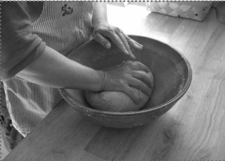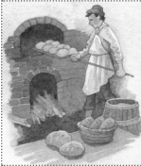
Students respond orally to a partner and to the class to the following:
- Look carefully at Document A. List as many details as you can from this image.

- Now look carefully at Document B. What do you see in this image?

- What colonial job do these two pictures represent?

- What tool(s) is the person using to do the job?

Writing Opportunity: What colonial job is shown in these pictures, and what tools are used? Why is this an important job?

Documents C, D, E
Document C Document D Document E
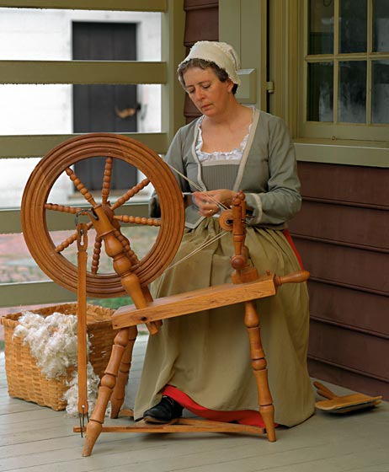

Students respond orally to a partner and to the class to the following:
- Make a list of everything you see in the documents.

- What colonial job do these three pictures represent?

- What tool(s) is the person using to do the job?

Writing Opportunity: What colonial job is shown in these pictures, and what tools are used? Why is this an important job?

